Name:G Shivani

Roll no:2520090046

SKILL WEEK-3

Session-5
Task1: To Apply Single Quotes, Preserve Literal Content, Ignore Variable Expansion, Store Quoted Strings, Validate Parsing Results, Test Edge Cases.
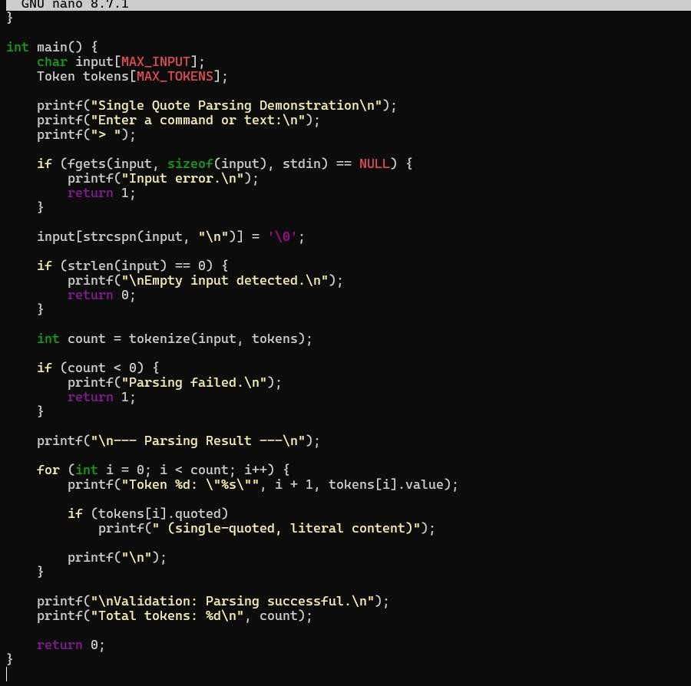

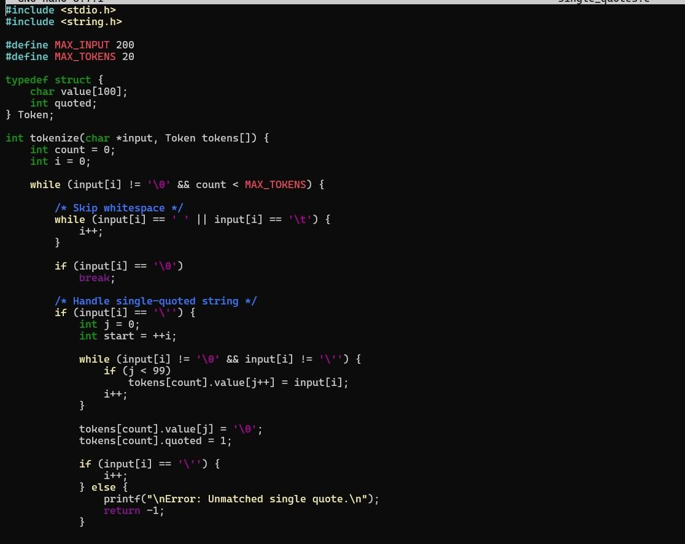
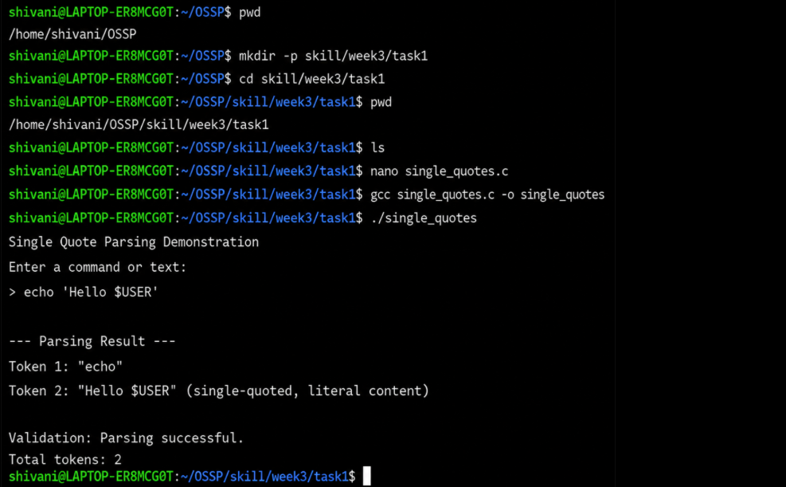
Observation: The program successfully processed single-quoted strings and preserved their contents as literal text. Variable expressions such as $USER inside single quotes were not expanded. The quoted strings were correctly stored as tokens, and the parsing results were validated successfully. The program also detected unmatched single quotes and handled empty input appropriately. Thus, single-quote handling, literal content preservation, token storage, parsing validation, and edge-case testing were successfully demonstrated.

Task2: To Apply Double Quotes, Preserve Spaces, Allow Variable Expansion, Parse Nested Tokens, Validate Outputs, Test Quoted Commands.
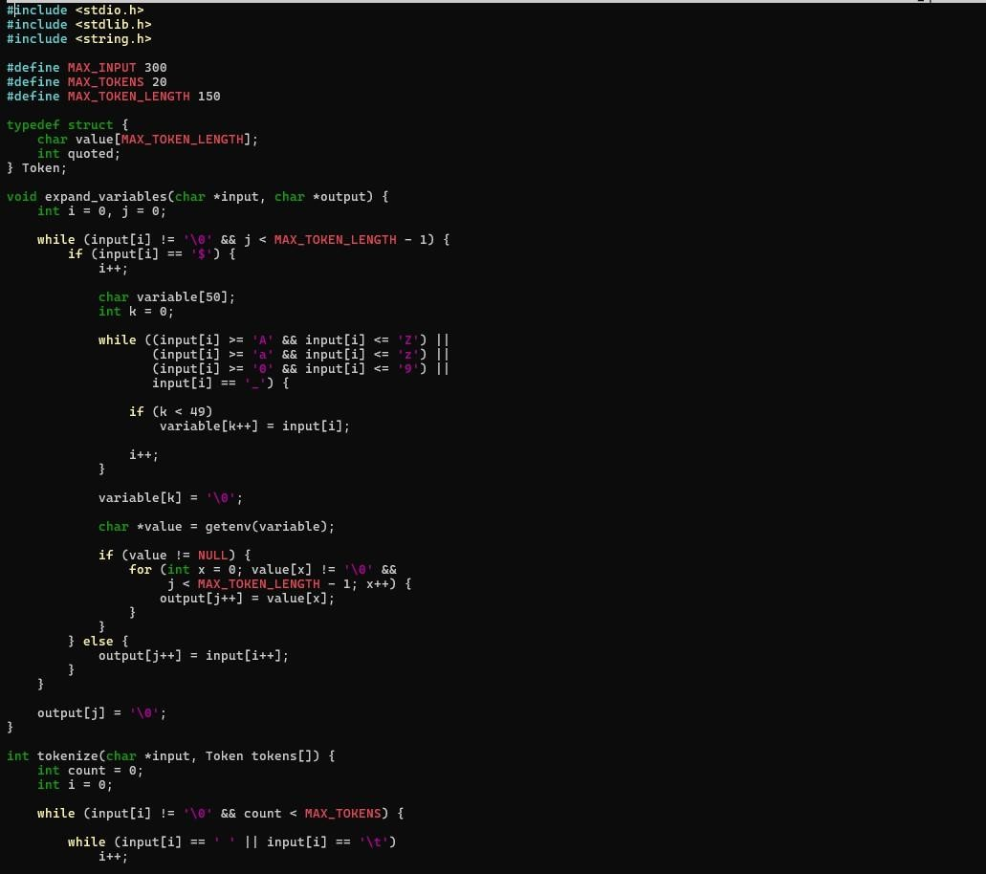
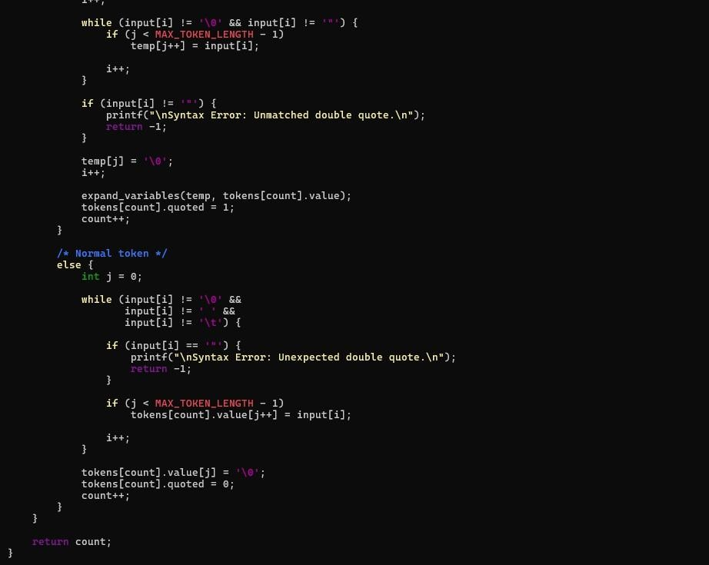

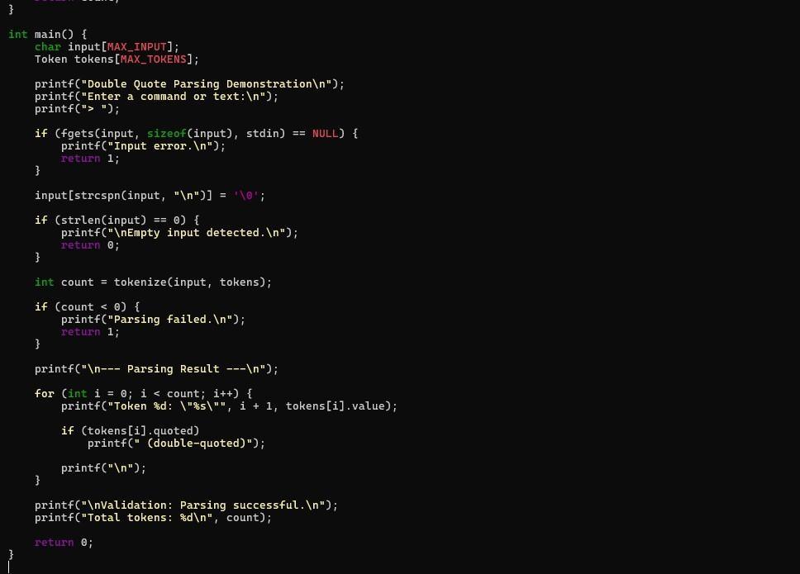
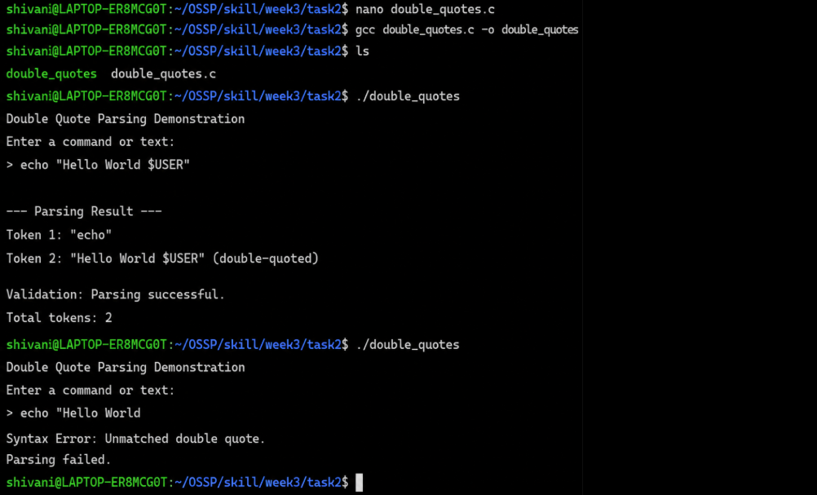
Observation: The program successfully processed double-quoted strings while preserving spaces within the quoted content. Variable expansion was correctly performed, with $USER replaced by the current username. The quoted command was parsed as a single token and the parsing result was validated successfully. The program also detected an unmatched double quote and reported a syntax error. Thus, double-quote handling, space preservation, variable expansion, quoted command parsing, output validation, and error detection were successfully demonstrated.

Session-6
Task1: To Create Process Escape Sequences, Handle Escaped Spaces, Escape Special Symbols, Preserve Characters, Validate Parser Output, Test Complex Inputs.
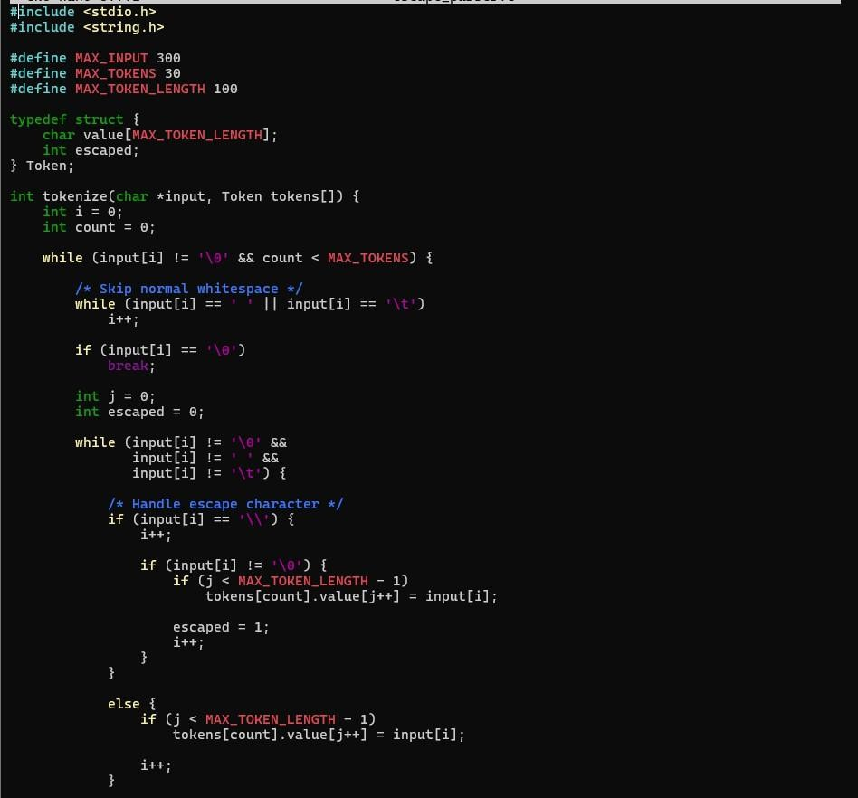

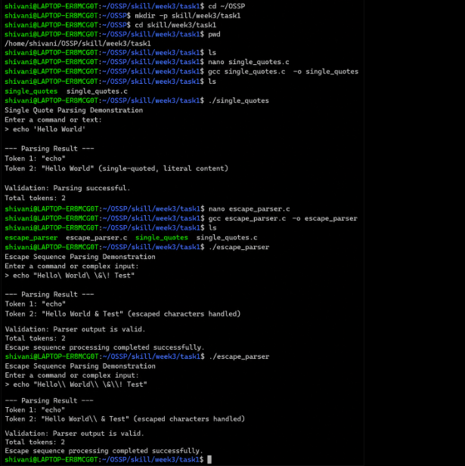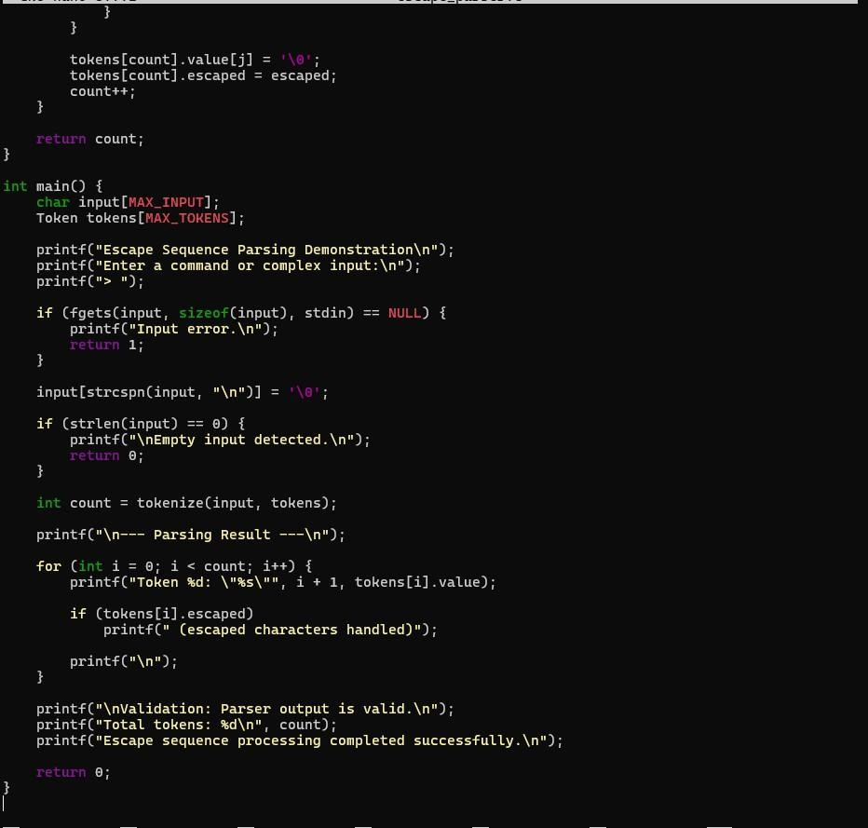

Observation: The program successfully processed escape sequences, handled escaped spaces and special symbols, and preserved the intended characters in the input. The parser correctly generated tokens from simple and complex inputs, and the resulting parser output was validated successfully. Thus, escape-sequence handling and parsing of complex inputs were successfully demonstrated.
Task2: To Create Child Processes, Execute Programs, Handle Execution Errors, Pass Arguments, Manage Parent Process, Test Command Launching.
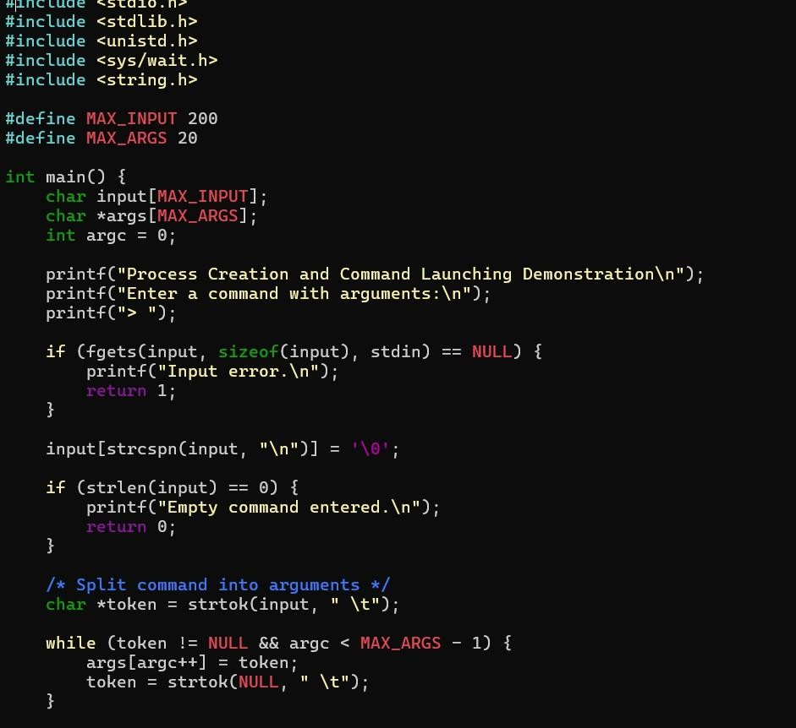

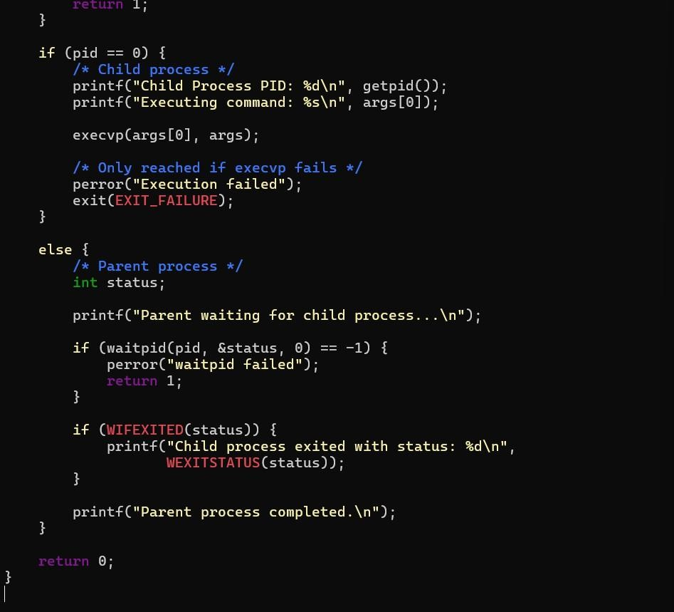

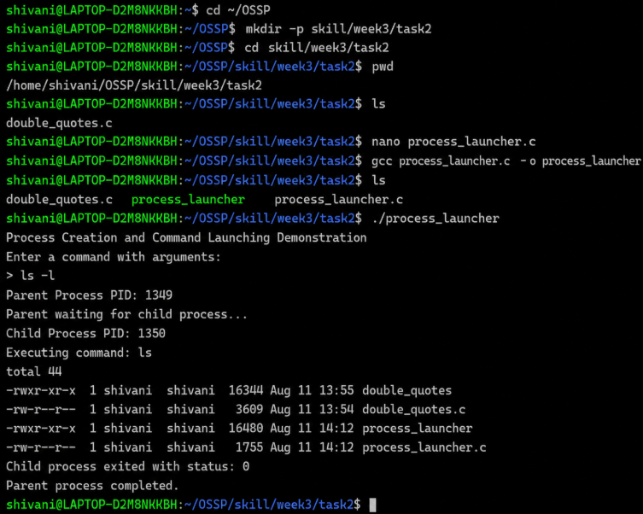

Observation: The program successfully created a child process using fork() and executed commands using execvp(). Command-line arguments were passed correctly to the child process, while the parent process waited for the child to complete using waitpid(). Invalid commands were detected and appropriate execution errors were displayed. Thus, child process creation, program execution, argument passing, parent process management, error handling, and command launching were successfully demonstrated.

